Instructions
CO 72 (84, 96) 120 sts, Place maker and join in the round being careful not to twist the work.
Work a K2, P2 rib for 1-2”
Knit in Stockinette stitch until the hat measures 4”(4.5”, 5”)6” from CO edge.
Decrease: switch to DPNs when needed.
Round 1 (dec): *K10, K2tog; repeat around. Round 2 & even rounds: Knit
Round 3 (dec): *K9, K2tog; repeat around. Round 5 (dec): *K8, K2tog; repeat around. Round 7 (dec): *K7, K2tog; repeat around. Round 9 (dec): *K6, K2tog; repeat around. Round 11 (dec): *K5, K2tog; repeat around. Round 13 (dec): *K4, K2tog; repeat around. Round 15 (dec): *K3, K2tog; repeat around. Round 17 (dec): *K2, K2tog; repeat around. Round 18 (dec): *K1, K2tog; repeat around.
Round 19 (dec): *K2tog; repeat around.
Use tapestry needle to thread yarn through remaining stitches. Cinch. Weave in ends.

DKA Basic Hat

DKA Basic Hat

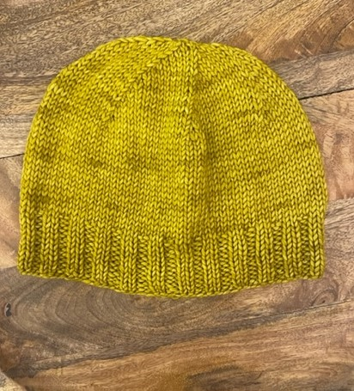

Instructions
CO 72 (84, 96) 120 sts, Place maker and join in the round being careful not to twist the work.
Work a K2, P2 rib for 1-2”
Knit in Stockinette stitch until the hat measures 4”(4.5”, 5”)6” from CO edge.
Decrease: switch to DPNs when needed.
Round 1 (dec): *K10, K2tog; repeat around. Round 2 & even rounds: Knit
Round 3 (dec): *K9, K2tog; repeat around. Round 5 (dec): *K8, K2tog; repeat around. Round 7 (dec): *K7, K2tog; repeat around. Round 9 (dec): *K6, K2tog; repeat around. Round 11 (dec): *K5, K2tog; repeat around. Round 13 (dec): *K4, K2tog; repeat around. Round 15 (dec): *K3, K2tog; repeat around. Round 17 (dec): *K2, K2tog; repeat around. Round 18 (dec): *K1, K2tog; repeat around.
Round 19 (dec): *K2tog; repeat around.
Use tapestry needle to thread yarn through remaining stitches. Cinch. Weave in ends.

Abbreviations

CO=Cast On
K=knit
P=Purl
K2tog=knit 2 sts. together
Sts=stitches

Materials
Yarn: 1 skein -Worsted; or 200 yrds

Needle: US 7 16” circular and DPNs

Notion: Tapestry needle
Finished Size
Youth (Teen, Med Adult) Lg Adult

Abbreviations

CO=Cast On
K=knit
P=Purl
K2tog=knit 2 sts. together
Sts=stitches

Materials
Yarn: 1 skein -Worsted; or 200 yrds

Needle: US 7 16” circular and DPNs

Notion: Tapestry needle
Finished Size
Youth (Teen, Med Adult) Lg Adult

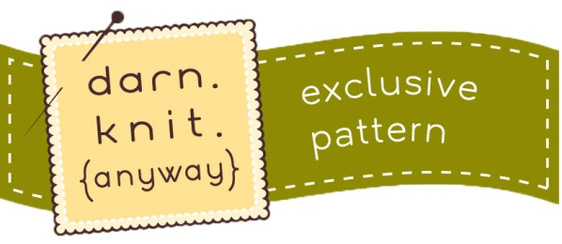
© 2022 darn. knit. {anyway}
423 s main street - stillwater, mn - 55082
651.342.1386 www.darnknitanyway.com

© 2022 darn. knit. {anyway}
423 s main street - stillwater, mn - 55082
651.342.1386 www.darnknitanyway.com

